Konsui Fighter Voice-Over Application Form
Circean Studios is currently searching for experienced voice actors to participate in the production of our new game, Konsui Fighter. We are searching for talent local to the Kansas City metro, but will consider applicants that show exemplary skill. Any long-distance or out-of-state applicants will be expected to record and submit their own audition sound files. If you do not have proper recording equipment and submit raw or low-quality sound files, your application will not be considered.
If you are interested, please fill out the application below and submit a general sample of your voice work.
Any voice work that is used in-game will be given full and complete credit to the voice actor. Some actors may find this useful to expand their professional portfolio.
Name: Click or tap here to enter name.
Email: Click or tap here to enter email.
Phone Number: Click or tap here to enter phone number.
Previous Voice Acting Experience: Click or tap here to enter text.
Character(s) Selected to do voice work: Click or tap here to enter character name.
Review the attached character description sheet and record a sample of how you would represent the voice of the character based on the provided phrase samples. Feel free to submit multiple recordings of different characters or styles.
We encourage you to be as creative as you’d like and add your own adlibs! Feel free to personify the character as you see fit. The more unique, the better!
Please email the completed application form and any MP3 or YouTube links of your voice samples to submit@circeanstudios.com
The due date for submissions is September 30th, 2017
If Selected
Voice work will include general battle sounds (grunts, hits, etc.) as well as catch phrases for each character.
Voice session will require approximately 1-3 hours to record.

Synopsis

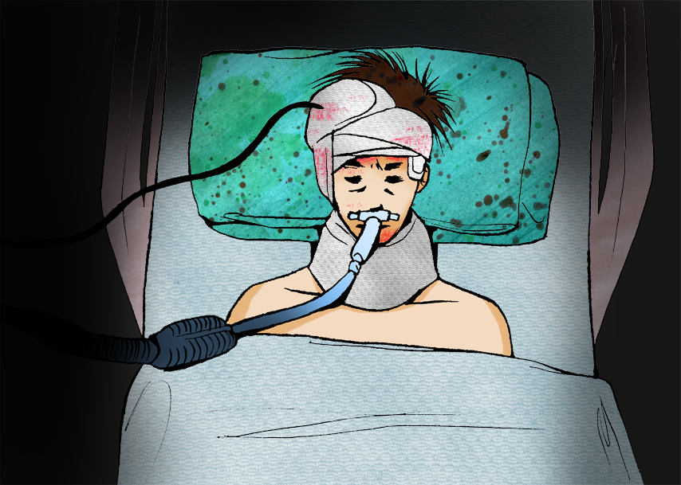

Trapped within a deep coma, Professor Ayumu Tsuburaya struggles to regain his memory of the events that led to his condition. Searching his inner mind for answers, the beings that make up the fabric of his personality begin to emerge, locked in conflict. As the Tournament of the Mind begins, will Ayumu's mind regain order, or will it remain forever lost in chaos?
Konsui Fighter is a traditional 2D fighting game for Android-based mobile devices created from the ground up by Kansas City based game developer Circean Studios. Konsui Fighter features all original hand-drawn artwork and animation from acclaimed artist Jas Carpenter. The story, game design, engine, code, and original soundtrack are produced by lead director Shayne Helms. Graphics and network subsystems, custom tools, and story engine are provided by developer Sean Cornett. Character frame colorization is provided by digital artists Leah Faulkner and Michelle Thomas. Press and marketing for Circean Studios managed by PR lead Logan Jensen.

Characters

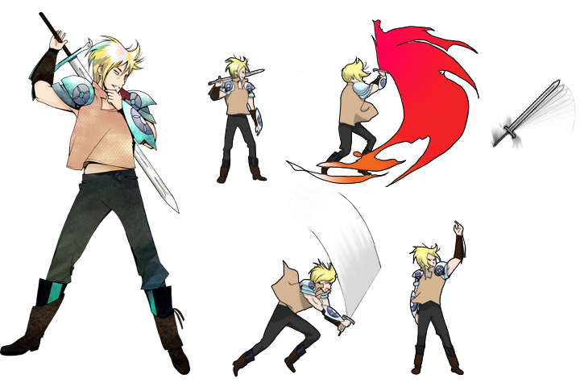 ISAMU
TRAIT: Courage
REALM: Hinode Castle
BACKGROUND: The youngest son of the Royal Family, Isamu is well known for his sword fighting skills. His rambunctious and sometimes downright cocky attitude has gotten him into trouble on more than one occasion, but he always manages to take care of himself. During preparations for the annual harvest festival, Isamu's older sister Reena is swept away into a mysterious vortex, sending him on a mission to recover her safely.
Isamu’s fighting style relies heavily on his skills as a swordsman. He features an upward strike that can launch an opponent into the air, a sword toss that can deliver multiple hits to airborne enemies, his deadly Dragon Slash maneuver (a sliding slash across the ground that erupts into flame), and multiple airborne sword attacks. His Super Special attack is a deadly sword spin, in which Isamu twirls several times with his sword extended.
PHRASE SAMPLES:
- Let’s see what you’re made of!
- Dragon slash!
- Try this on for size!
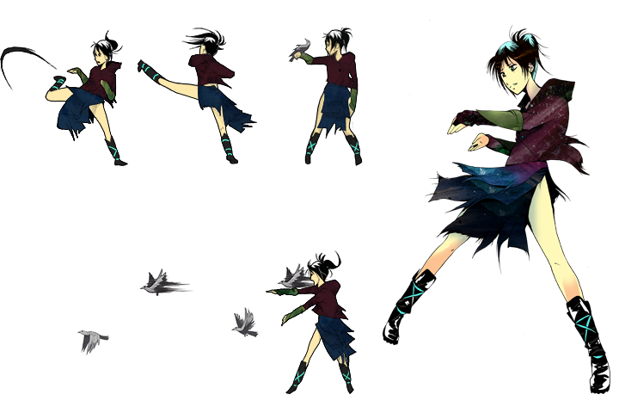 HITAN
TRAIT: Sorrow
REALM: Hayashi Temple
BACKGROUND: Hitan was left on the doorstep of the Sisters of Hayashi Temple, who raised her as one of their own. They taught her their sacred art, allowing Hitan to form a strong bond with the birds of the surrounding forest. Upon returning from the forest one day, Hitan finds the church ablaze, her sisters now perished in the flames. After burying her fallen sisters and paying her final respects, she begins a journey to discover the truth of her origins, and to bring justice to those who destroyed her only family.
Hitan uses a combination of kick maneuvers in conjunction with her bird swarm as her means of attack. Wherever Hitan goes, she has a cluster of birds that follow her around the arena. She has several special attacks at her disposal that launch birds from the swarm as projectiles. However, she has a limited number of birds in the swarm, and each has a cooldown period before it returns for use to the swarm. She also features a sliding roll kick that can launch enemies into the air, and a deadly double kick. Hitan has the ability to use her SS attack on the ground or from the air, launching all the birds in her swarm at the opponent.
PHRASE SAMPLES:
- Prepare yourself!
- All things must come to an end.
- Now my flock!
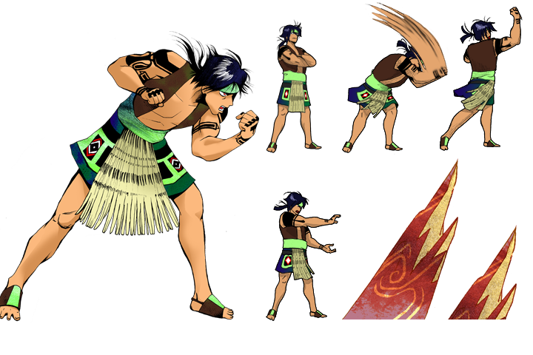 KENTA
TRAIT: Rage
REALM: The Arid Plains
BACKGROUND: Kenta’s tribe had survived for many years in the arid plains, but were finding resources to sustain them growing scarcer by the day. After the death of the Tribe’s chieftain, the elders challenged Kenta and his rival, Takuma, to find a new land for the tribe to determine the new chieftain. After many weeks of searching, Kenta discovered a lush jungle, the perfect home for his tribe. To his dismay, Kenta had been followed by Takuma, who quickly overpowered Kenta. Kenta awoke shortly thereafter to find himself deserted in an unfamiliar region of the plains. Filled with rage, Kenta now wonders the wasteland, searching for his tribe, and vengeance against the traitor Takuma.
Kenta may be a slower opponent, but he has many hard-hitting attacks at his disposal. Kenta features mostly ground-based attacks of a physical nature, such as a hard-hitting uppercut that launches the opponent into the air, a chest slam that knocks back opponents, and a head-bash. Kenta’s time in the Arid Plains has also given him the ability to call upon the earth to launch rock-based attacks at his opponents. Kenta has a boulder toss maneuver that hurls a large boulder at his opponent, and a rock spire maneuver that shoots spikes from the arena floor. His SS maneuver launches a trio of spikes in both directions that juggle the opponent away from Kenta for multiple hits.
PHRASE SAMPLES:
- I will break you!
- The rocks are mine to command.
- I have you now!
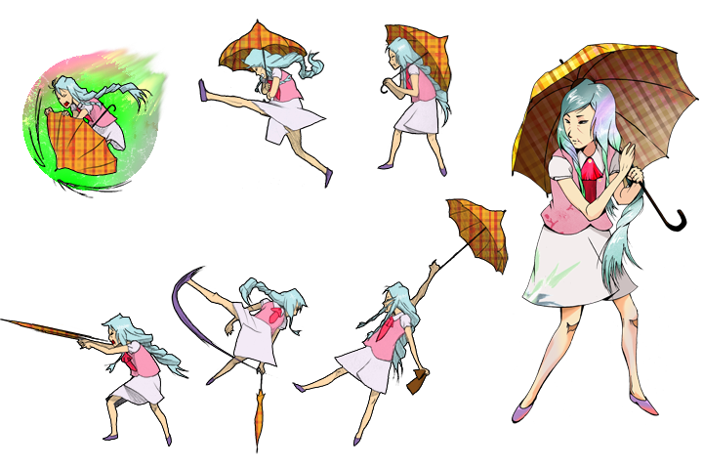 YASU
TRAIT: Peace
REALM: Yokuchi Village
BACKGROUND: Yasu is a well-respected member of Yokuchi Village, and maintains one of the most prosperous farms in the small village despite her age. There, she teaches many of the village children how to cultivate, passing her skills on to a new generation. During one lesson in the fields, a shadowy attacker appears, prompting Yasu to defend the children. After fending off the mysterious figure, Yasu embarks on a mission to find the source of the unusual assailant, to prevent further threats to their otherwise peaceful village.
Small, fast, and very balanced, Yasu’s fighting style relies on a series of rapid strikes against her opponents. Leveraging her trusty umbrella, she can launch a stream of never-ending rapid jabs at the opponent. She can also swipe the cane end of her umbrella at her opponents to trip them up and hurl them into the air. She has a sliding kick, as well as the ability to perform a spinning umbrella kick in midair that hits the opponent multiple times. For her SS attack, she tosses seed bombs at her opponent, knocking them into the air if hit. As this happens, she flies up into the air and hurls at her opponent, striking them again while in midair from the seed bombs.
PHRASE SAMPLES:
- My path is clear.
- A calm heart cultivates a wise mind.
- It is time to strike!
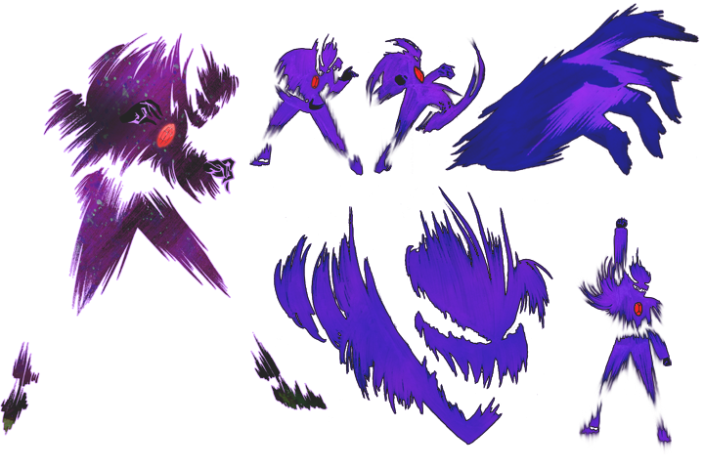 SHINROU
TRAIT: Terror
REALM: Realm of Shadow
BACKGROUND: Once a successful businessman, Shinrou was driven by a lust for power to seek out the legendary Bloodstone, rumored to grant the wishes of the one who possessed it. After a long expedition, he finally managed to find the lost artifact. Upon taking the crystal, Shinrou was pulled away into a dark and mysterious realm where objects failed to retain form, as he began to transform into a vaporous entity himself. For the last two-hundred years, Shinrou has searched in vain for escape from his shadowy prison, each day driving him further into madness.
Shinrou’s fighting style relies on his ability to change form. He features a roundhouse kick, a teleportation ability, and a flying punch up from the ground. In addition, he has the ability to transform into a large hand and squeeze his opponents, or to transform into a large head and chomp his way across the arena. For his SS attack, Shinrou transforms his arms into a large set of jaws that converge upon his opponent.
PHRASE SAMPLES:

Shinrou’s Voice Samples have been Recorded.
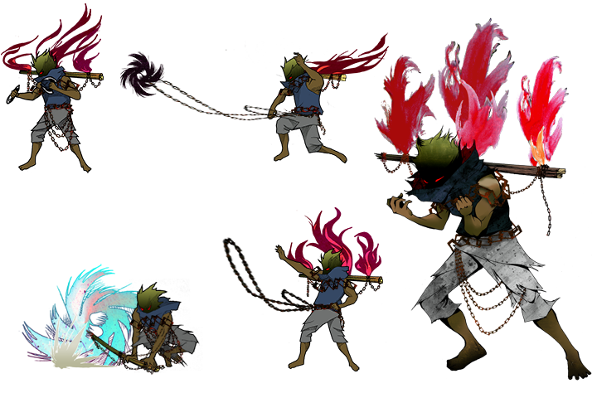 ITAMI
TRAIT: Torment
REALM: Kizamu Sanctuary
BACKGROUND: Itami is a member of The Hokage, a religious sect who believe that the outside world has become tarnished and corrupted by peace and inaction. Their solution is to cleanse the world with pain, washing away the balance and promoting new growth. Itami has begun the Path of Jikokeihatsu as his rite of passage, where he is awarded his Semedougu, the tools with which to carry out his faith's work. The Hokage send Itami forth into the outer world to exercise their beliefs, launching him on an expedition of self-discovery.
Itami utilizes the various Semedougu weapons in his encounters. He features several strong hits with his hand blades, as well as a boomerang he can hurl across the arena. Itami has a chain toss maneuver that draws in the opponent as he delivers a strong kick to them. He also has his large rotary blade, which he can toss at a distance attached to his chain to deliver multiple hits in the air. He can also cause a large burst of flames from his back that can hit airborne opponents. For his SS maneuver, Itami combines the power of his flames and rotary blade to carve his way across the arena floor.
PHRASE SAMPLES:
- Eternal flame, guide my blades!
- Another is cast in shadow.
- Atone for your purity!

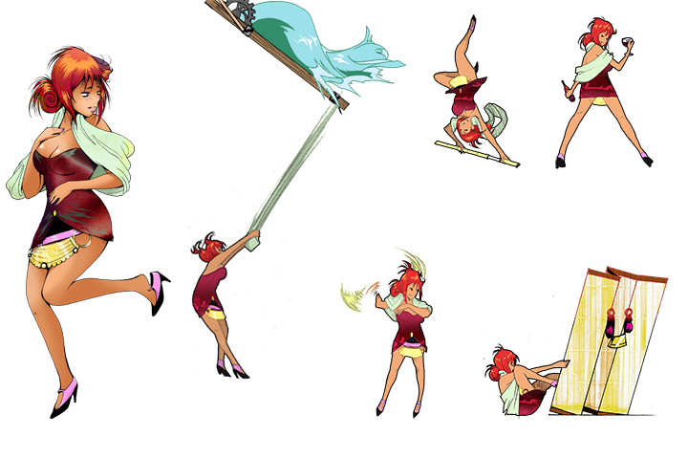 YURAKU
TRAIT: Pleasure
REALM: Kaiji City Massage House
BACKGROUND: Yuraku works at the infamous Kaiji City Massage House. While she is well respected within the House's clientele, Yuraku has a tendency to be disrespectful and demeaning to her coworkers. One day, Yuraku finds that her next client turns out to be a bigger handful than she imagined. This encounter sends her down the rabbit-hole on a path that causes her to question her self-centered ways.
Yuraku has a very dynamic fighting style, relying on her environment and various techniques. She features the ability to pull down a trap door of hot bath water at her opponents, and the ability to perform a backward roll that launches a folding screen that remains on stage briefly that shoots darts at the opponent. She also has the ability to perform a dashing twirl of her Bo staff launching and hitting the opponent multiple times in the air, as well as a twirling maneuver of her Bo staff in midair. She has a taunt move where she appears scared, but if hit regains a small portion of the damage as health. For her SS maneuver, Yuraku jumps into a hot water spring, as two false clones of herself emerge. These clones will deal strong counter attacks if provoked, but will dissipate if the real Yuraku is hit, or the effect expires.
PHRASE SAMPLES:
- Let’s release that tension.
- I always come out on top!
- Let’s heat it up!
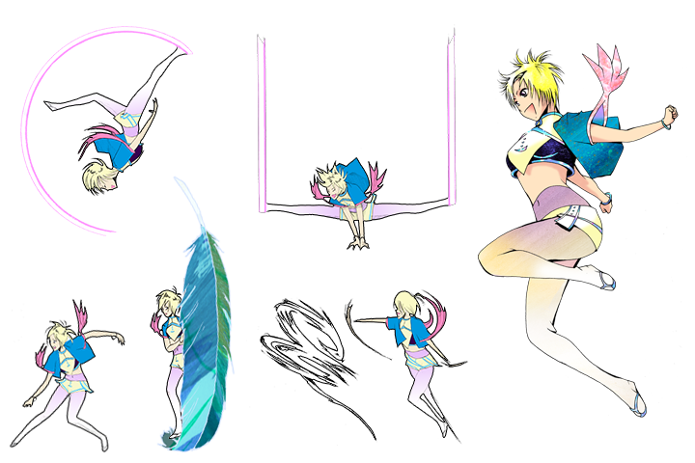 KYOUKI
TRAIT: Glee
REALM: Celestial City
BACKGROUND: Kyouki is the daughter of the chief engineer for Celestial City. Her mother passed away when she was young, and her father refuses to discuss what happened. The Ancient Celestial City was once inhabited by a technologically advanced civilization that constructed it, but all that remains of their society are a series of ruins on the outskirts of the hovering islands. Despite her father's warnings, she frequently explores the ruins with the aid of her aichou, a size-shifting bird, named Baku.
Kyouki is a very gymnastic fighter. She employs several physical feats for her special attacks, including an opponent-launching backflip, a trip-kick that launches the opponent into the air, a cartwheel, and a downward splits attack. For her SS maneuver, Kyouki spins and calls about a whirlwind that draws in nearby opponents and hits them back and forth multiple times before launching them into the air.
PHRASE SAMPLES:
- Time to step it up!
- That was awesome!
- Go for launch!

